8D7N Family Trip
日期  Date | 行 程  Itinerary | 飯 店  Hotel | 早  B | 午  L | 晚  D | 其 它  Remarks
Day 1  28-Dec  SAT | TAOYUAN –TAIPEI  SIN 15:45 – TPE 20:15  Taoyuan Airport Pickup –Transfer to Taipei Hotel | Hotel Papawhale  or comparable | EXC | EXC | EXC
Day 1  29-Dec  SUN | TAIPEI  Hotel depart –Chiang Kai Shek Memorial Hall –Taipei 101 (observatory ticket not included) –Tamsui Old Street –Shilin Night Market | Hotel Papawhale  or comparable | Hotel BF | EXC | EXC
Day 2  30-Dec  MON | TAIPEI –KAOHSIUNG  Hotel depart –Taipei sta. 08:51 HSR to Kaohsiung sta. - 10:30 Arrive Kaohsiung sta. –Fo Guang Shan Buddha Memorial Hall –Dragon and Tiger Pagodas –Ruifeng Night Market – Kaohsiung Hotel | Hotel Midtown Richardson Boai  or comparable | Hotel BF | EXC | EXC
Day 3  31-Dec  TUE | KAOHSIUNG –ALISHAN –CHIAYI  Hotel depart [3hr] –Alishan National Scenic Area [2hr] –Wenhua Rd. Night Market –Chiayi Hotel | Maison de Chine Hotel  or comparable | Hotel BF | EXC | EXC
Day 4  1-Jan  WED | CHIAYI –CINGJING  Hotel depart –Hinoki Village [2.5hr] –Cingjing Farm (Green Green Grassland, Small Swiss Garden, Trail) –Cingjing Guest House | Cingjing Farm Guest House  or comparable | Hotel BF | EXC | EXC
Day 5  2-Jan  THU | CINGJING – HUALIEN  Guest House depart [3hr] –Taroko Gorge –Qingshui Cliff –Dongdamen Night Market –Hualien Hotel | Ola Hotel  or comparable | Hotel BF | EXC | EXC
Day 6  3-Jan  FRI | HUALIEN –TAOYUAN  Hotel depart –Farglory Ocean Park – Qixingtan Beach [3.5hr] –Taoyuan Hotel | Tao Garden Hotel  or comparable | Hotel BF | EXC | EXC
Day 7  4-Jan  SAT | TAOYUAN  TPE 09:55 – SIN 14:30  Hotel free and easy –Transfer to Taoyuan Airport | On flight | Hotel BF | EXC | EXC

Quotation：
Based on Double/Twin Room
Minimum 8 PAX
*price is for reference only, can be adjusted based on final schedule*
8 PAX  (VIP Van + 1 Chinese speaking driver cum guide) | USD653 / Adult  1Child with bed shared room with 1 Adult, same fare as Adult USD653 p.p.  1Child with bed shared room with 2 Adult, charge USD490 p.p.  1Child without bed shared room with 2 Adult, charge USD392 p.p.（Age 2-6 yr old）
8 PAX  (Coaster Van + 1 Indonesian speaking TG) | USD828 / Adult  1Child with bed shared room with 1 Adult, same fare as Adult USD828 p.p.  1Child with bed shared room with 2 Adult, charge USD621 p.p.  1Child without bed shared room with 2 Adult, charge USD497 p.p.（Age 2-6 yr old）
備註
- 國籍 Nationality: Valid for Inbound Market
- 司導 Driver cum Guide: Mandarin speaking driver cum guide
- 交通 Transportation: 7 Seats VIP Van (max. 10HR/ day)
- 餐食 Meals: Breakfast
- 報價包含 Price included：Transportation/ Driver cum guide Service Fee/ Attraction Fee/ HSR one way ticket from Taoyuan to Kaohsiung/ Insurance
Insurance Included：NTD $5,000,000 Liability insurance & NTD $200,000 Medical insurance
Itinerary subject to change without period notice due to local operation problem
VIP Van
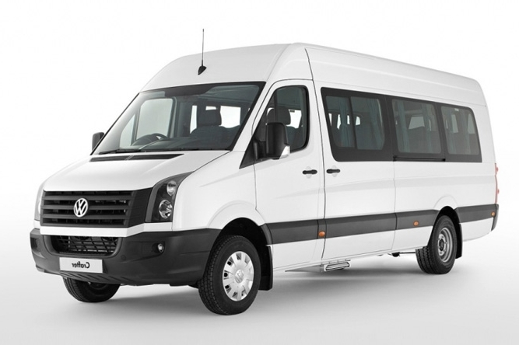
Coaster Van
